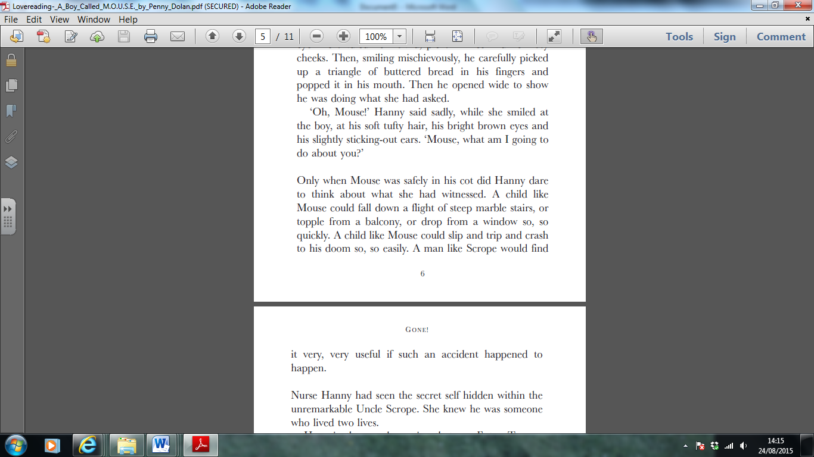
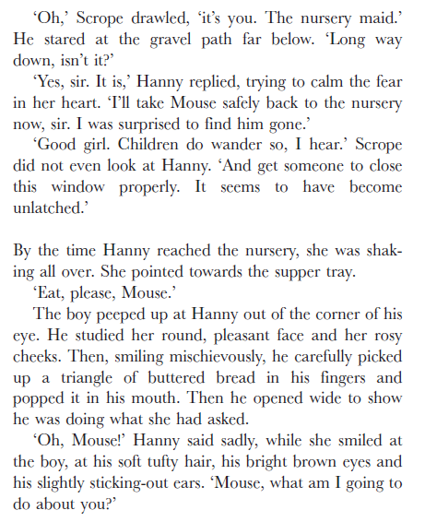
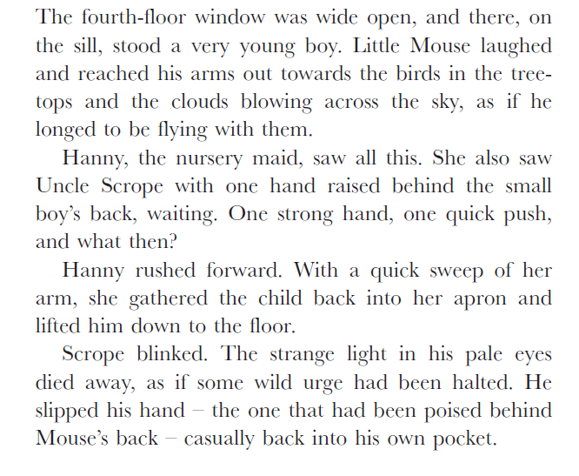
From ‘A Boy called M.O.U.S.E’ by Penny Dolan
Retrieving Information
- Use a dictionary to find the meaning of:
- urge
- poised
- What is Mouse having for supper?
- What time of day are the events in the text happening?
Making Inferences
- Do you think this text is set in the past or nowadays? Why?
- Why do you think Hanny says nothing about what she saw to Uncle Scrope?
- Why might Uncle Scrope want Mouse to have an ‘accident’?
Writer’s choices
- Why do you think the writer opens the text with a description of the birds and the trees and clouds?
- Why do you think the author has chosen to give Uncle Scrope “pale eyes” and Mouse “bright brown eyes”?
Challenge question (extended answer)
- Do you think Mouse comes from a rich or a poor family? Explain why, using evidence from the text.

