Continued
The Great Paper Caper
by Oliver Jeffers
The Hodgeheg
by Dick King-Smith
The Magic Faraway Tree
by Enid Blyton
The Owl Who Was Afraid of the Dark
by Jill Tomlinson
The True Story of the Three Little Pigs
by Jon Scieszka
The Twits
by Roald Dahl
Spells
by Emily Gravett
The Tunnel
by Anthony Browne
Pumpkin Soup
by Helen Cooper
The Huge Bag of Worries
by Virginia Ironside
Oi Dog!
by Claire Gray and Kes Gray

Suggested Books
The Big Alfie and Annie Rose Storybook
by Shirley Hughes
The Dinosaur That Pooped Christmas!
by Tom Fletcher
Fantastic Mr Fox
by Roald Dahl
Flanimals
by Ricky Gervais
Flat Stanley
by Jeff Brown
Fe! Fi! Fo! Fum!
by Twinkl Originals
George's Marvellous Medicine
by Roald Dahl
Horrid Henry
by Francesca Simon
Little Wolf's Book of Badness
by Ian Whybrow
Man on the Moon
by Simon Bartram
Mr Majeika
by Humphrey Carpenter
On the Way Home
by Jill Murphy
The Princess and the Pea
by Lauren Child
The Day the Crayons Quit
by Drew Daywalt

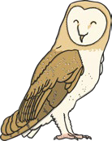

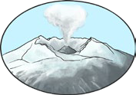

Brilliant Book List Y2
Essential reading for every Year 2!
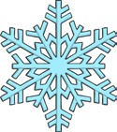
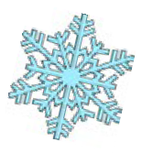
Suggested Books
Amazing Grace
by Mary Hoffman
Bubble and Squeak
by James Mayhew
The Diary of a Killer Cat
by Anne Fine
The Emperor of Absurdia
by Chris Riddell
Goth Girl and the Ghost of a Mouse
by Chris Riddell
Grandad’s Island
by Benji Davies
Jo-Jo and the Melon Donkey
by Michael Morpurgo
Katie and the Bathers
by James Mayhew
The Katie Morag Treasury
by Mairi Hedderwick
Katie and the Waterlily Pond
by James Mayhew
Lila and the Secret of Rain
by David Conway
Meerkat Mail
by Emily Gravett
My Teacher Is an Alien
by Bruce Covill



Brilliant Book List Y2
Essential reading for every Year 2!
Continued
Paddington
by Michael Bond
Peace At Last
by Jill Murphy
The Lighthouse Keeper’s Lunch
by Ronda Armitage
The Magic Finger
by Roald Dahl
The Night Pirates
by Peter Harris
The Penguin Who Wanted to Find Out
by Jill Tomlinson
The Story Tree
by Hugh Lupton
Traction Man
by Mini Grey
Tuesday
by David Weisner
Where the Wild Things Are
by Maurice Sendak
The Worst Witch
by Jill Murphy
Mrs Pepperpot Stories
by Alf Proysen

