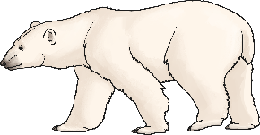
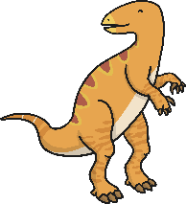
Brilliant Book List EYFS
Essential reading for every foundation stage child!
Ten in the bed
by Penny Dale
Ten Little Dinosaurs
by Mike Brownlow
The Duck and the Truck
by Jez Alborough
The Gruffalo’s Child
by Julia Donaldson
The Highway Rat
by Julia Donaldson
The Jolly Postman
by Allan Ahlberg and Janet Ahlberg
The Scarecrows’ Wedding
by Julia Donaldson
The Snail and the Whale
by Julia Donaldson
The Tiger Who Came Tea
by Judith Kerr
The Very Hungry Caterpillar
by Eric Carle
There Was an Old Lady Who Swallowed a Fly
by Pam Adams
Tiddler
by Julia Donaldson
Tiny Seed
by Eric Carle
We’re Going on a Bear Hunt
by Michael Rosen
What the Ladybird Heard
by Julia Donaldson
Where the Wild Things Are
by Maurice Sendak
Where’s Spot?
by Eric Hill
Aliens Love Underpants
by Claire Freedman
Brown Bear, Brown Bear
by Eric Carle
Dear Zoo
by Rod Campbell
Dogger
by Shirley Hughes
Each Peach Pear Plum
by Allan Ahlberg and Janet Ahlberg
Elmer
by David McKee
Giraffes Can’t Dance
by Giles Andreae
Gruffalo
by Julia Donaldson
Guess How Much I Love You
by Sam McBratney
Handa’s Surprise
by Eileen Browne
Meg and Mog
by Helen Nicholl
Oliver’s Vegetables
by Vivien French
Peace At Last
by Jill Murphy
Peepo!
by Allan Ahlberg and Janet Ahlberg
The Rainbow Fish
by Marcus Pfister
Room and the Broom
by Julia Donaldson
Shark in the Park
by Julia Donaldson and Axel Scheffler
Tabby McTat
by Julia Donaldson
Argh Spider
by Lydia Monks
Continued
Suggested Books
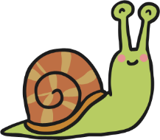
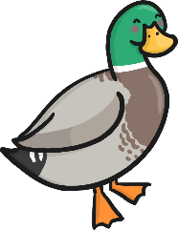
Brilliant Book List EYFS
Essential reading for every foundation stage child!
Suggested Books
Dr Xargle’s Book of Earthlets
by Jeanne Willis
Father Christmas Needs A Wee
by Nicholas Allan
The Paper Dolls
by Julia Donaldson
Pumpkin Soup
by Helen Cooper
The Naughty Bus
by Jan Oke
Not a Stick
by Antoinette Portis
Not a Box
by Antoinette Portis
A Children’s Treasury of Milligan
by Spike Milligan
Commotion in the Ocean
by Giles Andrae
Rumble in the Jungle
by Giles Andrae
You Choose
by Nick Sharratt

