Y1 homework
We continue to keep working through the revision of the phase 3 sounds and therefore we will be recapping a number of sounds this week and will not ask for any items to be emailed for our phonics display.

Please remember to keep reading (we suggest 4 times per week) and practice spelling your Rocket Words for a spelling test every Thursday afternoon. As soon as your child can spell all the words on their card they will graduate to the next card. All of the words on the cards are from the Y1 Common Exception word list and so they are really important to learn.

Attached to this note is reading & maths homework to complete. If the children could answer all Qs in full sentences it will aid their writing & the first maths Q has been done to show you. Once complete, please take a photo and upload onto Tapestry for me to see rather than sending back into school (Covid19 restrictions).

Enjoy your family weekend and have lots of fun. Remember to keep updating Tapestry with photos and videos of what you get up to. We love to see them.

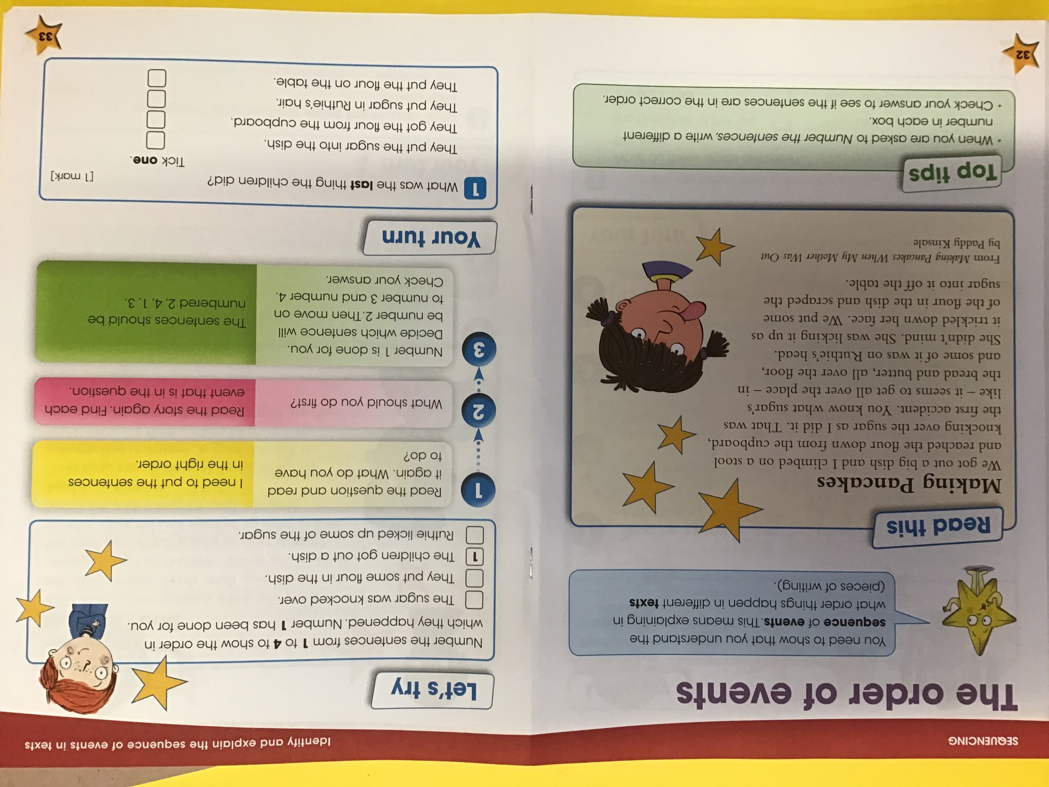

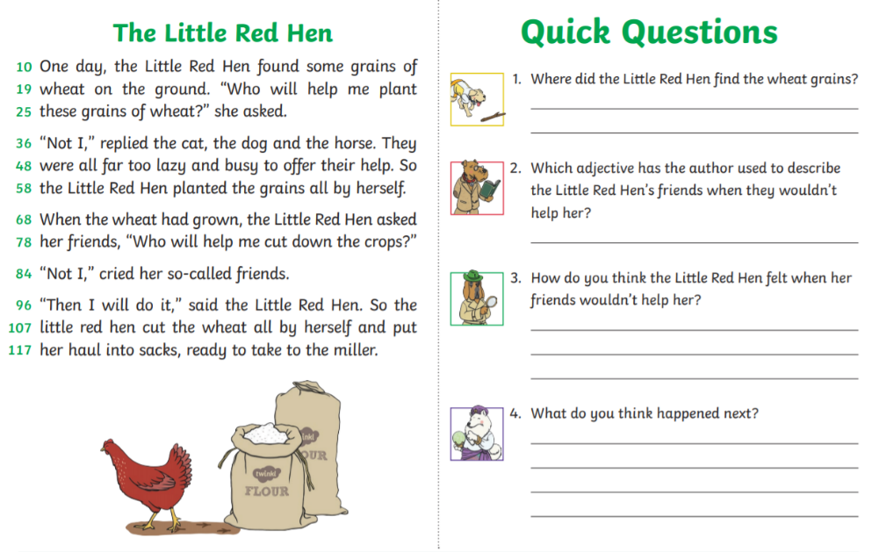

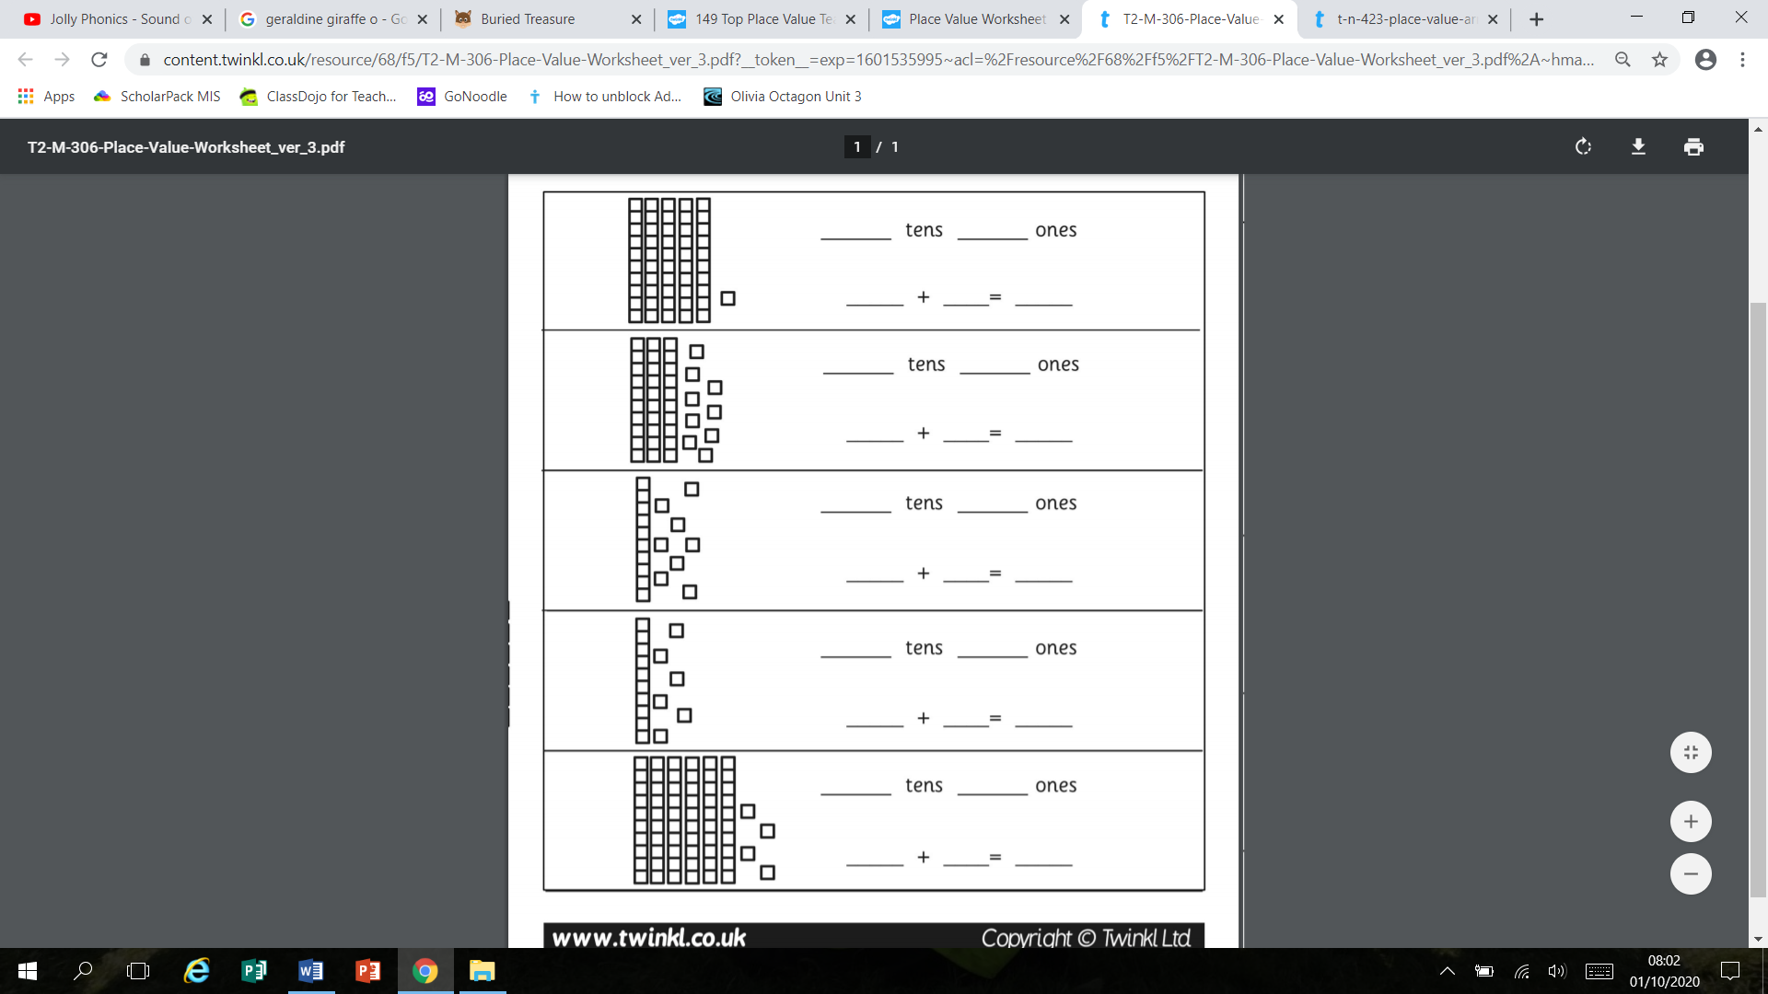
51
50
1
1
5

