Dear Parents and Carers,
We’ve had a wonderfully busy and fun half term based on the topic ‘Splendid Skies’ & of course ‘Christmas’. We have been learning all about the story of Christmas, written a letter to Santa, been baking, are now able to read and solve simple addition calculations and had lots of fun with Christmas crafts.
Well done Holbeck children, every day you make us…PROUD!
We have a half term homework project that the children can choose to take part in. I’d like the children to chose their most favourite story book and create a shoebox model for it. This is something that is done in many schools around and the country therefore you can google images for ideas by typing in ‘Book in a Box’, and Holbeck class did this last year with great results.
Once your child has chosen their story, they are to look at the setting and make the shoe box resemble that setting then make props or characters that go into the setting. This helps the children to develop their understanding of ‘setting’, ‘character’ and gives plenty of opportunities to verbally describe them in order to make them using a variety of resources and materials.
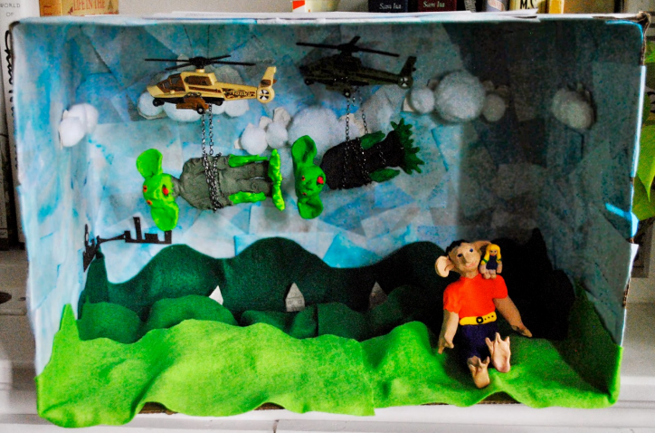
As always, whatever the result is, there is never a wrong project, just a wonderful display of individuality at the end of all their hard work.
Have a fantastic family Christmas!


