
English Curriculum Coverage 2025-26
Year 3 & 4, Year 3, Year 4
Reading | Writing
Word Reading | Writing Transcription
Decoding:  *Apply their growing knowledge of root words, prefixes and suffixes (etymology and morphology) as listed in English Appendix 1, both to read aloud and to understand the meaning of new words they meet  *Read further exception words, noting the unusual correspondences between spelling and sound, and where these occur in the word | Phonic and whole word spelling:  *Spell further homophones  *Spell words that are often misspelt (English Appendix 1)  Other word building spelling:  *Place the possessive apostrophe accurately in words with regular plurals: e.g. girls’, boys’ and in words with irregular plurals: e.g. children’s  *Use further prefixes and understand how to add them (English Appendix 1)  *Use further suffixes and understand how to add them (English Appendix 1)  *Use the first two or three letters of a word to check its spelling in a dictionary  Transcription:  *Write from memory simple sentences, dictated by the teacher, that include words and punctuation taught so far  Handwriting:  *Use the diagonal and horizontal strokes that are needed to join letters and understand which letters, when adjacent to one another, are best left unjoined  *Increase the legibility, consistency and quality of their handwriting: e.g. by ensuring that the downstrokes of letters are parallel and equidistant; that lines of writing are spaced sufficiently so that the ascenders and descenders of letters do not touch.
Comprehension
Range of Reading:
*Develop positive attitudes to reading and understanding of what they read by listening to and discussing a wide range of fiction, poetry, plays, non-fiction and reference books or textbooks *Read books that are structured in different ways and read for a range of purposes
Familiarity with texts:
*Identify and discuss themes and conventions in a wide range of writing
*Read an increasingly wide range of books, including fairy stories, myths and legends, and retell some of these orally
*Increase their familiarity with a wide range of books, including fairy stories, myths and legends, and retell some of these orally
*Identify and discuss themes and conventions in and across a wide range of writing
Poetry and Performance:
*Recognise some different forms of poetry, (e.g. free verse, narrative poetry)
*Prepare poems and plays to read aloud and to perform, showing understanding through intonation, tone and volume so that the meaning is clear to an audience
Word meanings:
*Use dictionaries to check the meaning of words that they have read
Understanding:
*Understand what they read by checking that the book makes sense to them, discussing their understanding and exploring the meaning of words in context
*Ask questions to improve their understanding
*Identify main ideas drawn from more than one paragraph and summarise these
*Check that the text makes sense to them, discussing their understanding and explaining the meaning of words in context
Inference:
*Draw inferences such as inferring characters’ feelings, thoughts and motives from their actions and justify inferences with evidence
Prediction:
*Understand what they read, in books they can read independently, by: predicting what might happen from details stated and implied
Authorial Intent:
*Develop positive attitudes to reading and understanding of what they read by discussing words and phrases that capture the reader’s interest and imagination
*Identify how language, structure and presentation contribute to meaning
*Discuss words and phrases that capture the reader’s interest and imagination
Non-Fiction:
*Retrieve and record information from non-fiction
Discussing Reading:
*Participate in discussion about both books that are read to them and those they can read for themselves, taking turns and listening to what others say

Writing Composition
----------------------------------------------------------------------------------------------------------
Contexts for Writing:
*Plan their writing by: discussing writing similar to that which they are planning to write in order to understand and learn from its structure, vocabulary, and grammar.
Planning and Drafting Writing:
*Plan their writing by discussing and recording ideas
*Compose and rehearse sentences orally (including dialogue), progressively building a varied and rich vocabulary and an increasing range of sentence structures
*Organise paragraphs around a theme
*In narratives, create settings, characters and plot
*In non-narrative material, use simple organisational devices: e.g. headings and sub-headings
Editing Writing:
*Assess the effectiveness of their own and others’ writing and suggest improvements
*Propose changes to grammar and vocabulary to improve consistency, including the accurate use of pronouns in sentences
*Proof-read for spelling and punctuation errors
Performing Writing:
* Perform their own compositions, using appropriate intonation, volume, and movement so that meaning is clear

 | Writing – Vocabulary, Grammar and Punctuation
Vocabulary:
*Form nouns using prefixes (super-, anti-)
*Word families based on common words (solve, solution, dissolve, insoluble)
Grammar:
* Choose nouns or pronouns appropriately for clarity and cohesion and to avoid repetition
* Extend the range of sentences with more than one clause by using a wider range of conjunctions, including when, if, because, although
*Use conjunctions, adverbs and prepositions to express time and cause
*Use the present perfect form of verbs in contrast to the past tense
*Use the correct form of ‘a’ or ‘an’ according to whether the next word begins with a consonant or vowel
Punctuation:
Use Inverted commas to punctuate direct speech
*Use of inverted commas and other punctuation to indicate direct speech
*Use commas after fronted adverbials
*Use apostrophes to mark plural possession

English Curriculum Coverage 2025-26
Langwith Class
Reading Objectives |  | Writing Objectives
Year 3 & 4
  Read aloud and understand words based on knowledge of root words, prefixes and suffixes
  Read further exception words, including those with unusual spelling/sound links
  Retell some fairy tales or traditional tales orally
  Identify themes and conventions in a range of books
  Perform plays and poetry aloud using intonation, tone, volume and action
  Recognise some different forms of poetry
  Use dictionaries to check the meanings of words
  Check that a text makes sense, including explaining the meaning of words in context
  Identify and summarise the main ideas drawn from more than one paragraph
  Draw inferences about feelings thoughts and motives
  Use evidence to justify inferences
  Discuss words and phrases which capture the reader's interest
  Identify how language contributes to meaning
  Identify how structure and presentation contribute to meaning
  Retrieve and record information from non-fiction texts
  Spell words which are often misspelt from the Y3-4 list
  Use the possessive apostrophe accurately with plurals
  Use a dictionary to check a spelling
  Use appropriate handwriting joins, including choosing unjoined letters
  Adopt the features of existing texts to shape own writing
  Build sentences with varied vocabulary and structures
  Organise paragraphs around a theme
  Develop detail of characters, settings and plot in narratives
  Use simple organisational devices in non-fiction
  Suggest improvements to grammar and vocabulary
  Proofread own work for spelling and punctuation errors
  Read aloud using appropriate intonation, tone and volume
  Use a range of conjunctions to extend sentences with more than one clause
  Choose nouns and pronouns for clarity and cohesion
  Use conjunctions, adverbs and prepositions to express time, cause & place
  Use fronted adverbials
  Understand the difference between plural and possessive '-s'
  Recognise and use standard English verb inflections
  Use extended noun phrases, including with prepositions
  Use and punctuate direct speech correctly

 | Langwith Class – 2025/26  Teacher: Ben Haynes-Greenwood
English LTP 2023-24
Unit | Term/week | Genre/Write | Focus/Texts | Composition and GPS features
1 | Aut 1  W2-3 | Fiction – Descriptive writing | 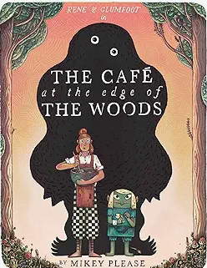  Cafe at the edge of the woods by Mikey Please | - Use the correct form of ‘a’ or ‘an’ according to whether the next word begins with a consonant or vowel  - Choose nouns or pronouns appropriately for clarity and cohesion and to avoid repetition  - Use simple organisational devices in non-fiction  - In non-narrative material, use simple organisational devices: e.g. headings and sub-headings  - Use expanded noun phrases, including with prepositions
2 | Aut 1  W4-6 | Fiction – Adventure stories | 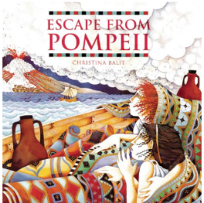  Escape from Pompeii by Christina Balit | - Use of apostrophes for single and plural nouns  - Use and punctuate direct speech  - Use devices to build cohesion, including adverbials of time, place and number.  - Use the present form of verbs in past tense  - Use a range of conjunctions to create compound and complex sentences.  - Use expanded noun phrases, including with prepositions
3 | Aut 1  W7 | Poetry - Autumnal | Various examples | - Organise paragraphs around a theme  - Read aloud using appropriate intonation, tone and volume  - Plan their writing by discussing and recording ideas
4 | Aut 2  W8-9 | Instructions - recipes | Cross-curricular with D/T | - Use the present perfect form of verbs in contrast to the past tense  - Use the perfect form of verbs to mark relationships of time and cause.  - Use conjunctions, adverbs and prepositions to express time and cause.  - Use commas after fronted adverbials  - Use imperative verbs to give instructions.
5 | Aut 2  10-12 | Persuasive Writing – Villa for sale | Estate agent brochures  NF texts on Roman homes | - Plan their writing by: discussing writing similar to that which they are planning to write in order to understand and learn from its structure, vocabulary, and grammar.  - In non-narrative material, use simple organisational devices: e.g. headings and sub-headings  - Organise paragraphs around a theme  - Use expanded noun phrases, including with prepositions
6 | Aut 2  W13 | Poetry - Wintry | Various examples | - Organise paragraphs around a theme  - Read aloud using appropriate intonation, tone and volume  - Plan their writing by discussing and recording ideas
7 | Spring 1  W1-2 | Newspaper Report – Natural disaster | Various examples     | - Use conjunctions, adverbs and prepositions to express time and cause.  - Use commas after fronted adverbials  - Plan their writing by: discussing writing similar to that which they are planning to write in order to understand and learn from its structure, vocabulary, and grammar.  - Organise paragraphs around a theme  - Proofread own work for spelling and punctuation errors
8 | Spring 1  W3-5 | Explanation Texts – Hanging Gardens of Babylon | 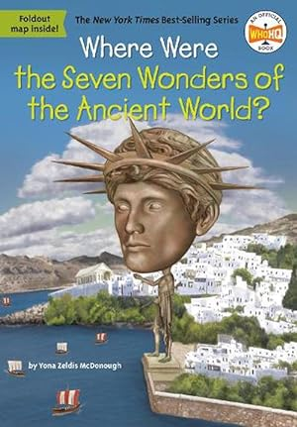  BG’ example. | - Plan their writing by: discussing writing similar to that which they are planning to write in order to understand and learn from its structure, vocabulary, and grammar.  - Organise paragraphs around a theme  - Assess the effectiveness of their own and others’ writing and suggest improvements  - Extend the range of sentences with more than one clause by using a wider range of conjunctions, including when, if, because, although  - Use conjunctions, adverbs and prepositions to express time and cause  - Use apostrophes to mark plural possession
9 | Spring 2  7-9 | Non-Chronological Report – Natural disasters | Various examples | - Use brackets to indicate parenthesis  - Use simple organisational devices: headings & subheadings  - Organise paragraphs around a theme  - Extend the range of sentences with more than one clause by using a wider range of conjunctions, including when, if, because, although
10 | Spring 2  10-11 | Book Review | 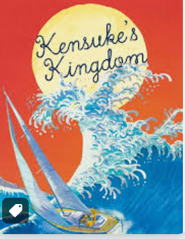  Michael Morpurgo – Kensuke’s Kingdom | - Identify and discuss themes and conventions in a wide range of writing  - Identify main ideas drawn from more than one paragraph and summarise these  - Organise paragraphs around a theme  - Plan their writing by discussing and recording ideas
11 | Spring 2  W12 | Poetry - Haikus | 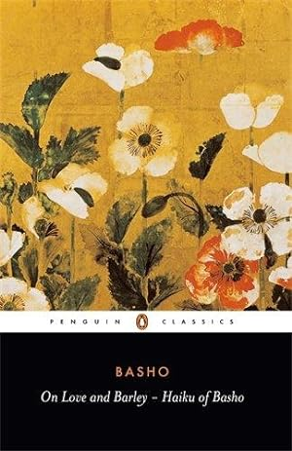   | - Recognise some different forms of poetry  - Prepare poems and plays to read aloud and to perform, showing understanding through intonation, tone and volume so that the meaning is clear to an audience  - Draw inferences such as inferring characters’ feelings, thoughts and motives from their actions and justify inferences with evidence
12 | Summer 1  W1-3 | Non Fiction:- Mythical beast catalogue | Self-Made | - Use brackets to indicate parenthesis  - Use simple organisational devices: headings & subheadings  - Organise paragraphs around a theme  - Extend the range of sentences with more than one clause by using a wider range of conjunctions, including when, if, because, although  - Use expanded noun phrases to add detail.
13 | Summer 1  W4-6 | Fantasy Fiction:- Adventure stories. | Jason & The Argonauts  Pegasus  Icarus | - Use of apostrophes for single and plural nouns  - Use and punctuate direct speech  - Use devices to build cohesion, including adverbials of time, place and number.  - Use the present form of verbs in past tense  - Use a range of conjunctions to create compound and complex sentences.  - Use expanded noun phrases, including with prepositions
13 | Summer 2  W8-10 | Tradition Tales:- Aesop’s Fables | 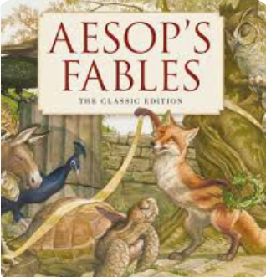 | - Use of apostrophes for single and plural nouns  - Use and punctuate direct speech  - Use devices to build cohesion, including adverbials of time, place and number.  - Use the present form of verbs in past tense  - Use a range of conjunctions to create compound and complex sentences.  - Use expanded noun phrases, including with prepositions
14 | Summer 2  W11-13 | Extract writing - description | 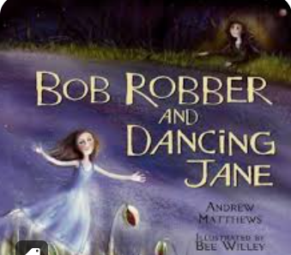  Bob Robber and Dancing Jane by Andy Matthews | - Use of inverted commas and other punctuation to indicate direct speech  - Use commas after fronted adverbials  - Use apostrophes to mark plural possession  - Choose nouns or pronouns appropriately for clarity and cohesion and to avoid repetition  - Extend the range of sentences with more than one clause by using a wider range of conjunctions, including when, if, because, although  - Use conjunctions, adverbs and prepositions to express time and cause  - *Use the present perfect form of verbs in contrast to the past tense

