
Y1: 6th September 2019

Y1: 6th September 2019
This week we have been practising counting reading and writing numbers up to 100 in numerals and to 20 in words.
This week’s homework is to complete the counting objects tasks below.

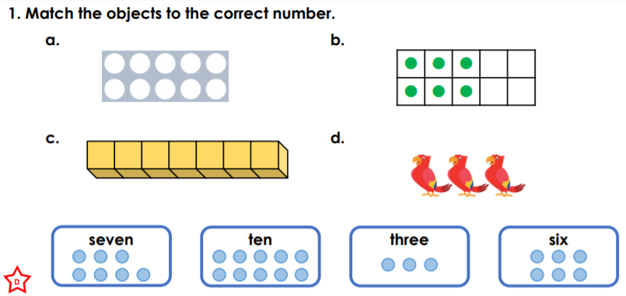

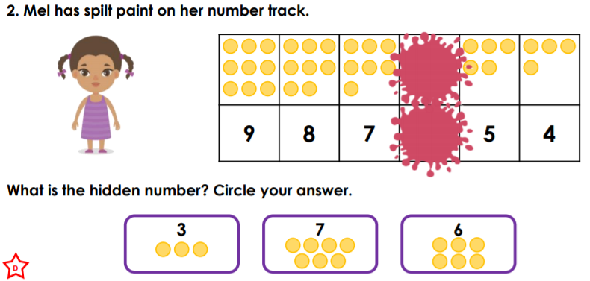

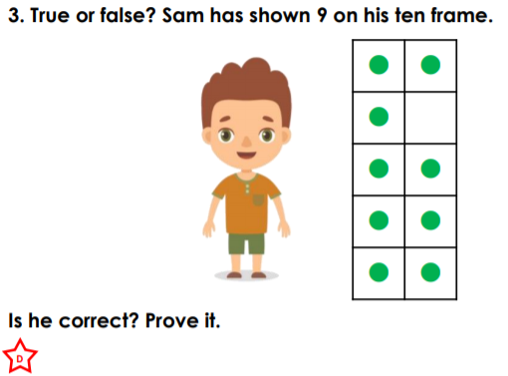



Y2: 6th September 2019
This week we have been practising counting reading and writing numbers up to 100 in numerals and words.
This week’s homework is complete the counting objects tasks below.



