 |   Last week | This week
English | Adjectives  Can you write a sentence to describe this puppy?    Challenge: Use the power of three in your sentence eg. The cute, fluffy, little puppy. | Conjunctions  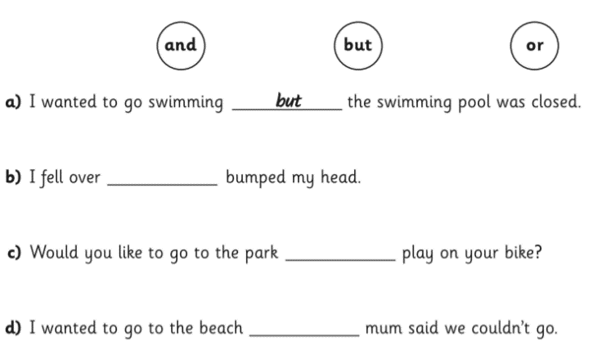  Can you complete the sentences with an appropriate conjunction?  Challenge: Think of your own sentences to join with each conjunction.
Maths | Representing numbers  Can you write the number in numerals and words  Challenge: Make up your own problems to solve with numbers to 100 | One more/one less  Practice with an adult throwing a ball or soft toy to each other. When the adult throws the toy they say a number to 100. When you throw it back you need to say the number one less as quickly as possible. See if you can get quicker each time.  Challenge:  - Adult challenging by alternating saying one more than or one less than each time  - Saying one less than 20, 30, 40, 50, 60, 70, 80, 90  - Saying one less than a number greater then 100
  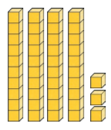
  
  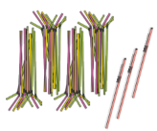
  Topic |           We will be making our own land art inspired by Andy Goldsworthy next week. It would be really helpful if you could collect as many fallen leaves as you can over the weekend to help with this. A range of shapes and sizes would be fabulous!!

