 |   Last week | This week
English | Phonics ‘ai’ and ‘ay sounds  Can you use the ‘ai’ or ‘ay’ digraph to spell these words correctly? Remember ‘ai’ is usually at the beginning of a word and ‘ay’ is usually at the end.            Challenge: Can you write these words in a sentence. | -ed words  Can you change these sentences into the past tense using an –ed word?  Bob is washing his car.  Sally works really hard.  Bill cooks his dinner.  Challenge: How many –ed words can you think of? Set yourself a timer and write as many as you can think of in 2 minutes!
Maths | 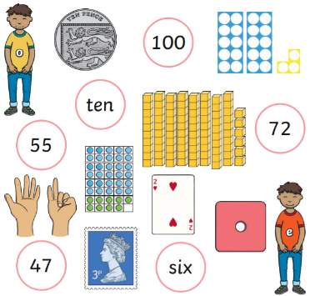  Odd and even numbers  Can you circle the even numbers  and tick the odd numbers?  Challenge: True or false…When  you add two odd numbers  together it always makes an even  number. | Ordering numbers  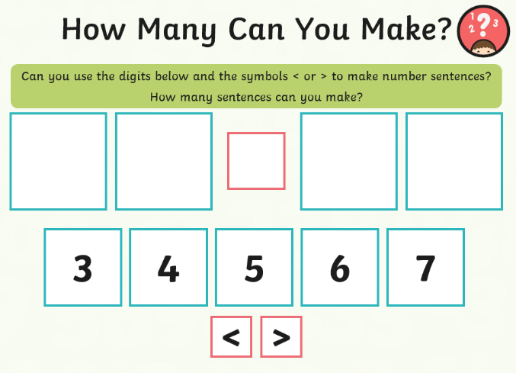  Challenge: Can you make 3 digit numbers to compare?
Topic | Next week in science we will be identifying common wild and garden plants. See how many different types of tree you can spot while you are out and about this weekend, or maybe in your own garden. Perhaps you could try and identify some of them. The Woodland Trust have some great things on their website to help you https://www.woodlandtrust.org.uk/naturedetectives/activities/2015/09/leaf-id/

