The daily explorer
Egg-straordinary escape from death!
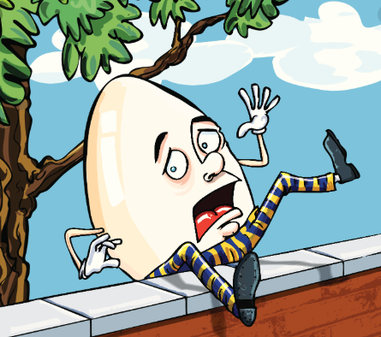 | call for assistance. The first on the scene were the King's horses and men, but despite their best efforts they could not put Mr Dumpty back together and all seemed lost. However, paramedics from the local hospital were more successful, and Mr Dumpty is now recovering in hospital.  Local shepherdess Bo Peep, who saw the accident, told us what happened.  "I was just out looking for my sheep when I heard a terrible, smashing sound," she said. "I really thought that he had been killed, but I'm so relieved to hear that he is going to get better."  Mr Dumpty's family have thanked well-wishers for their gifts and cards. It is hoped that he will be released from hospital in a few days.
The moment our favourite celebrity took a tumble.
Yesterday afternoon, the well-known local celebrity Humpty Dumpty was lucky to escape with his life after falling from a four-metre high wall in the local park onto hard concrete. He is currently being treated in hospital.
It is believed that Mr Dumpty was sunbathing on the wall at around two o'clock yesterday afternoon when he nodded off to sleep and toppled forwards. Shockingly, he fell to the ground and shattered into dozens of pieces.
Luckily, horrified onlookers used their mobile phones to

