Ice Breaker Investigation
Background
Specially built ships which sail through ice covered waters are called ice breakers. The ice can be as thick as three metres. They help to create safe routes for other ships to follow. They’re designed specifically for that job with a strengthened hull, a shape made to push ice out of its path and the power to push through the sea ice.
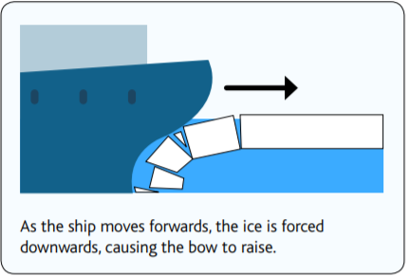
The hull of a ship is below the water line and includes the part of the bow (front of a ship) below the water line. Bows are shaped so that when the ship moves forward, the ice is pushed under it. As it does this the bow raises and the ice is crushed under the ship’s weight. Unlike the usual pointed bow shape of boats, ice breakers are slightly more rounded. The pointed bow creates a streamlined shape for boats to slice through waves and reduces the friction caused by the water contact. The smoother shape of an ice breaker allows the ship to move easily through the thick ice, forcing it downwards until it snaps under the ship’s weight and then push the broken ice out of the way to avoid damage. This activity will look at a ship’s hull shape. You will examine which shape is more efficient at moving sand out of the way, as a model of the high friction caused by ice on the water. You will also discuss the forces acting on ships as they move through the water and ice.
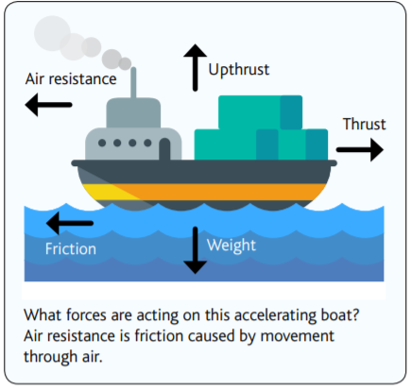
Resources
Water/sand tray or sealed guttering on a table
Sand/ flour
String (attach one end to the boat and the other to a weight)
Weight x 2 (you could use potatoes instead) (for inside the boat and to attach to the end of the string)
Stopwatch
Mixed Recyclables eg. Egg box, Corrugated plastic, Paper, cardboard
Scissors
Split pins

Introduction
The design of a ship depends upon the purpose or job the ship has to do. Look at the pictures of different boats and ships. What do they think the boat’s job is? Why do they look different? Why are they designed like that? How does the shape help?
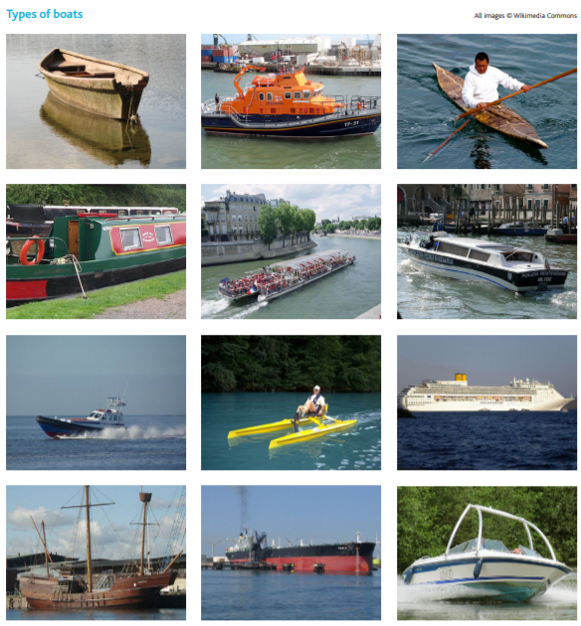

When anything moves through water it will encounter resistance (a force). This force is friction which is caused by the contact of the water and the boat. Rub your hands together you can feel friction as your two hands rub together, heat. What do you think will happen if a boat has more or less friction? friction slows a moving object down
Watch: https://www.youtube.com/watch?v=qRYJyqYKJnc&feature=youtu.be
Discuss what makes travel more difficult for polar ships. The RRS Sir David Attenborough can travel through ice 1m that thick. Would it be easy or hard travelling through thick ice? Think about trying to walk/run through snow? Is it as easy or hard? Why? friction and that this will create more resistance

Investigation
We will be exploring the best shape for the hull of a ship as it passes through sand. Discuss the forces that will be acting on the ship as it moves through the sand. The sand will cause high fiction, like the ice which the ice breaker ships encounter. The toy ship will need to push the sand out of its path for it to move forward.
- Frist you will need to make a ship with two hull shapes. One from the front of their ship and one from the back (you could make 2 ships if that is easier). Predict which hull will pass through the sand the easiest?
- Attach a piece of string to the front on the ship.
- Put it in the sand at the far side of the tray with a weight inside.
- Stretch the string to the other end of the tray and dangle over the edge.
- Attach a weight to the end of the string.
- Time how long it takes the string to get the floor.
- Record the results in a table.

This can be repeated three times and an average found.
Why we would repeat the test. Turn the toy ship around and attach the string to the back. Repeat the investigation for this hull shape.

Finally, discuss which hull shape was best. Why do they think this was the case? Look at a photograph of an ice breaker design and decide why it is shaped like that.

