Thoresby Home Learning W/B 29th June 2020

Theme: Polar Explorer

Dear Thoresby,
This week you will become polar explorers finding our all about our planets coldest regions. You will explore how animals and humans survive in cold weather and what adaptions they have to help. Write a non-chronological report on your chosen artic animal. As well as planning your very own expedition.

Follow the daily tasks, which have been divided into ‘AM’ and ‘PM’ to do the work alongside children attending school. Having said this please do continue to work how you see best and what is working for your child.
Each week I will post the resources needed to support learning. Of course, I will be teaching Monday to Friday this week, so replies to home leaner emails will be less prompt.
Many thanks for your continued support with home learning.
Miss Scrivener
dscrivener@cuckney.notts.sch.uk

Timetable Overview

Monday | Spelling sheet | Comprehension | Break | TTRS | Maths | Lunch | Reading | Topic
Tuesday | Spelling sheet | English | Break | TTRS | Maths | Lunch | Reading | Topic
Wednesday | Spelling sheet | English | Break | TTRS | Maths | Lunch | Reading | Topic
Thursday | Spelling sheet | English | Break | TTRS | Maths | Lunch | Reading | Topic
Friday | Spelling sheet | English | Break | TTRS | The Mystery of the Missing Racket | Lunch | Reading | Topic

 | Activity Overview | Task | Resources Needed | Teacher/Parent Notes
Monday AM | Spelling Sheet | Printing: Statutory Spelling Words PDF – use one sheet per day  OR  Online: https://spellingframe.co.uk/ choose a spelling list for the week | - Statutory Spelling Words PDF | Resources needed: Wednesday investigation: salt and eggs  Thursday investigation: plastic bottle
Monday AM | English | This week you will produce your very own non-chronological report.  What does 'Non-Chronological' mean? Not time ordered.  Explore the Non-Chronological report models  Can you identify features that are specific to a non-chronological report?  A feature often found in non-chronological reports is the use of less common punctuation, i.e. bullet points, dashes, semi-colons & colons.  Check your list of features against the checklist | 1b. British Science Week Non-Chronological  1b. Non chron report model  1b. Sharks Non-Chronological  1b. Tutankhamun Non-Chronological  1b. features checklist
Monday AM | TTRS | Printed: Complete 1 sheet – 3-minute timer, mark and keep your own record of your score over the week. Can you improve?  OR  Online: TTRS 10 minute play | TTRS Sheet
Monday AM | Maths | WhiteRose: Week 10 | Support Videos: Accessed via the white rose website: https://whiterosemaths.com/homelearning/  Worksheets:  1c. Year 4 Lesson 1 - Interpret charts  1c. Year 5 Lesson 1 - Measuring with a protractor (2)  (Answer sheets available) | WhiteRose is working with Bitesize Daily Lessons. Therefore, for a more interactive approach you could watch these lessons.
  Year 4 | Year 5
  Interpret charts | Measure with a protractor
Monday PM | Reading | MyOn – Polar Explorer Project  Read at least 2 of the saved books  Read 10 minutes per day – this can be their own book, a magazine, a news article, a recipe or an online MyOn book.  OR  Complete an AR Quiz
Monday PM | Topic | You will think about the different survival strategies animals in temperate regions employ in order to survive through the winter. You will compare these strategies to adaptations exhibited by animals in the Polar Regions, and will identify the similarities and differences between the ways in which animals are adapted to survive the changing environmental conditions in winter.  Your research will be used in English! | 1d. Animals Over Winter Presentation  1e. Animals Over Winter Worksheet  1f. Animals over winter Instructions  1g. Animals Over Winter extension activity

 | Activity Overview | Task | Resources Needed | Teacher/Parent Notes
Tuesday AM | Spelling Sheet | Printing: Statutory Spelling Words PDF – use one sheet per day  OR  Online: https://spellingframe.co.uk/ work on your spelling list | Statutory Spelling Words PDF
Tuesday AM | English | Remind yourself of the features of a NC report.  Look at the example text.  Using highlighters or coloured pencils – find these features  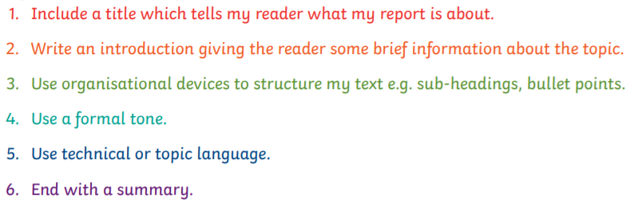  Can you find any others? | 2b. Example Text  2b. Answers to Features
Tuesday AM | TTRS | Printed: Complete 1 sheet – 3-minute timer, mark and keep your own record of your score over the week. Can you improve?  OR  Online: TTRS 10 minute play | TTRS Sheet
Tuesday AM | Maths | WhiteRose: Week 10 | Support Videos: Accessed via the white rose website: https://whiterosemaths.com/homelearning/  Worksheets:  2c. Year 4 Lesson 2 - Comparison sum and difference  2c. Year 5 Lesson 2 - Drawing lines and angles accurately  (Answer sheets available)
  Year 4 | Year 5
  Comparison, sum and difference | Drawing lines and angles accurately
Tuesday PM | Reading | Read 10 minutes per day – this can be their own book, a magazine, a news article, a recipe or an online MyOn book.  OR  Complete an AR Quiz
Tuesday PM | Topic | Learners will use Scratch, to debug and then improve a program to move Autosub6000 around the ocean floor, photographing samples found. When encountering a creature, Autosub6000 will say “Photographing sample…” before then saying “You have found a ...” The sample will then disappear. The remote movement will be controlled through a keyboard’s arrow keys initially and then the children will be challenged to create a program which will move Autosub6000 autonomously | 2d. AutoSubB6000 Activity

 | Activity Overview | Task | Resources Needed | Teacher/Parent Notes
Wed AM | Spelling Sheet | Printing: Statutory Spelling Words PDF – use one sheet per day  OR  Online: https://spellingframe.co.uk/ work on your spelling list | Statutory Spelling Words PDF
Wed AM | English | You are going to write your own Non-chronological report on your Artic animal  (Home school learners- Use the animal you researched on Mondays PM – In-school learners will need to complete research today)  Decide on your subheadings  Options:  Appearance  Distribution  Diet  Habitat  Life Cycle/Young  Conservation status  Relationship with humans  Plan each paragraph  Check back on your checklist, have you included everything you need to? | In School - 3b. Polar-Animals-Fact file-Sheets  3b. Writing A Non Chronological Report
Wed AM | TTRS | Printed: Complete 1 sheet – 3-minute timer, mark and keep your own record of your score over the week. Can you improve?  OR  Online: TTRS 10 minute play | TTRS Sheet
Wed AM | Maths | WhiteRose: Week 10 | Support Videos: Accessed via the white rose website: https://whiterosemaths.com/homelearning/  Worksheets:  3c. Year 4 Lesson 3 - Introducing line graphs  3c. Year 5 Lesson 3 - Calculating angles on a straight line  (Answer sheets available)
  Year 4 | Year 5
  Introducing line graphs | Calculate angles on a straight line
Wed PM | Reading | Read 10 minutes per day – this can be their own book, a magazine, a news article, a recipe or an online MyOn book.  OR  Complete an AR Quiz
Wed PM | Topic | You will explore density and the effect that adding salt to water has on floating and sinking eggs. It demonstrates why things float more easily in our oceans. | 3d. Salty Seas

 | Activity Overview | Task | Resources Needed | Teacher/Parent Notes
Thursday AM | Spelling Sheet | Printing: Statutory Spelling Words PDF – use one sheet per day  OR  Online: https://spellingframe.co.uk/ work on your spelling list | Statutory Spelling Words PDF
Thursday AM | English | Using your plan write your own non-chronological report. Focus on the text today  Remember your checklist! Don’t forget to edit
Thursday AM | TTRS | Printed: Complete 1 sheet – 3-minute timer, mark and keep your own record of your score over the week. Can you improve?  OR  Online: TTRS 10 minute play | TTRS Sheet
Thursday AM | Maths | WhiteRose: Week 10 | Support Videos: Accessed via the white rose website: https://whiterosemaths.com/homelearning/  Worksheets:  4c. Year 5 Lesson 4 - Calculating angles around a point  4c. Year 4 Lesson 4 - Line graphs  (Answer sheets available)
  Year 4 | Year 5
  Line graphs | Calculate angles around a point
Thursday PM | Reading | Read 10 minutes per day – this can be their own book, a magazine, a news article, a recipe or an online MyOn book.  OR  Complete an AR Quiz
Thursday PM | Topic | You will investigate how a submarine descends and ascends through making a Cartesian diver.  Video explaining process: https://www.youtube.com/watch?v=DU8wONWjIXg  Follow the instructions to make your own.  This investigation links with submarines, as submarines work through water displacement just as your diver does. They carry tanks of compressed air which helps to control their buoyancy. Surrounding a submarine are ballast tanks, which, when filled with water, allow it to dive through increasing its density of the submarine. When the submarine is ready to rise, the water in the ballast tanks is displaced by air from compression tanks, decreasing the density of the submarine causing it to rise to the surface.  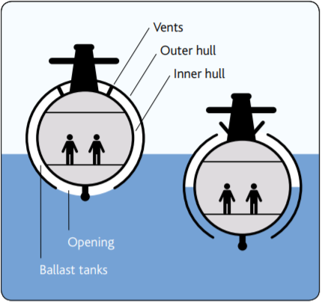 | 4d. Cartesian Diver

 | Activity Overview | Task | Resources Needed | Teacher/Parent Notes
Friday AM | Spelling Sheet | Printing: Statutory Spelling Words PDF – use one sheet per day  OR  Online: https://spellingframe.co.uk/ work on your spelling list | Statutory Spelling Words PDF
Friday AM | English | Complete your write  Ensure you plan your layout, non-chronological reports have photos, diagrams and subheadings.
Friday AM | TTRS | Printed: Complete 1 sheet – 3-minute timer, mark and keep your own record of your score over the week. Can you improve?  OR  Online: TTRS 10 minute play | TTRS Sheet
Friday AM | Maths | Planning an Antarctic Expedition  You will be using your mathematical skills and scientific knowledge to help plan for an expedition to the Antarctic. They will consider the appropriate clothing, food and other essential equipment they will need to take with them. | 5c. Planning an Antarctic Expedition  5d. Antarctica Expedition Presentation  5e. Clothing Catalogue  5f. Food Catalogue  5g. Equipment Catalogue
Friday PM | Reading | Read 10 minutes per day – this can be their own book, a magazine, a news article, a recipe or an online MyOn book.  OR  Complete an AR Quiz
Friday PM | Topic | Cont. Planning An Antarctic Expedition

