Salty Seas
Background
Salt water is denser than freshwater. That is why we float so much more easily in the sea than in a lake or a swimming pool. An object will float if it is less dense than the water surrounding it. Therefore, things float easier in salt water as it is denser than freshwater. This is particularly evident in the Dead Sea where the salt content is higher.
When you put an egg into freshwater, it will sink to the bottom. This is because the density of the egg is greater than that of the water. Adding salt increases, the water’s density. So, keep adding it and eventually the egg becomes less dense than the salt water and begins to float.
Resources
- 3 tall beakers or clear drinking glasses
- Tap water
- Salt
- A tablespoon
- 3 eggs (the same size)
Introduction
Have you ever swum in the sea? Was it easier or harder than in freshwater? What about floating?
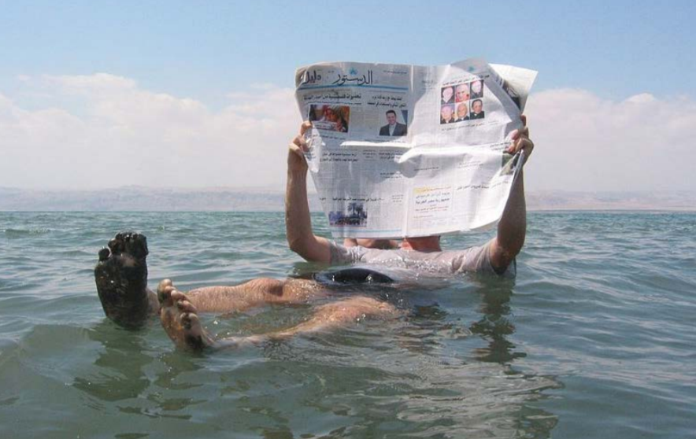
Why is this photo different to normal?
Discuss what the you think will happen if an egg is placed in a beaker of tap water. Will it be different if we put it in salty water? Why?
Activity
Set up three beakers so they can all have the same capacity of water in them.
Fill beaker one with tap water.
In beaker two, put two tablespoons of salt and the fill half way with tap water and stir to dissolve most of the salt. Add more tap water to the same point as beaker one and then stir again to dissolve the remaining salt.
Repeat for beaker three with four tablespoons of salt.
Carefully drop an egg (of the same size) into each beaker.
Observe what happens
Extension
Can the children design an experiment to find out exactly how much salt is needed to make an egg float?

