Week beginning Monday 15th June - Home Schooling Activities
As lock down continues we have chosen to provide you with more academic work, this will support your child’s learning and ensure they are ready when we are safely allowed to return to school.
Please continue doing what is working for your child. If completing all the English in one day is what works then great, if your child wants to finish all the maths first before starting the English then do that. I can’t stress enough do what works for you!
- English Activities
Activities to be completed in order
1 | Complete the work booklet – The King of the Fishes  You have had 2 weeks to complete this booklet.  Do not rush the writing, focus on one section at a time. Ensuring this is the best it can be (inspiring vocabulary choices, varied sentence structures etc.) and editing it before moving onto the next section, read at aloud does it make sense? Have the impact you hoped for?  Taking it further: If you have completed this writing task have a go at the Aliens booklet (Resources 1b) Writing your own adverts!  - Please note our donations have been made -
2
3
4
5

2. Reading Activities
Activities to be completed in any order
1 | Read 10 minutes per day – this can be their own book, a magazine, a news article, a recipe or an online MyOn book.
2 | Complete an AR Quiz

3. Grammar, Punctuation and Spelling Activities
Activities to be completed in any order
1 | SPaG Activity Mats –Choice a difficulty levels and review knowledge
2 | Statutory Spelling Words
3 | Handwriting Sheets – These don not need to be completed in one sitting but focus on the sizing and formation of your letters.

4. Maths Activities
Activities to be completed in order
We will be using the WhiteRose session these provide you with a teaching video and worksheet – Week 8
 | Year 4  Follow this link for teaching videos: https://whiterosemaths.com/homelearning/year-4/ | Year 5  Follow this link for teaching videos: https://whiterosemaths.com/homelearning/year-5/
1 | Write decimals | Understanding percentages
2 | Compare decimals | Percentages as fraction and decimals
3 | Order decimals | Adding with the same number of decimal places
4 | Round decimals | Adding decimals with a different number of decimals places
5 | Maths Challenge – The most suitable questions for Year 4 and 5 are 1, 2, 3, 4 and 5. But why don’t you work with family on the rest with your family. Do as many as you can!

5. Mental Maths and Arithmetic Activities
Activities to be completed in any order
1 | Times Table Rock Stars – 10-15 minutes per day will keep up your skills. If you don’t have access to this use the paper copied saved- 1 sheet per day.
2 | Arithmetic Test- Choose either Year 4 or Year 5. This is a review of previous and current knowledge. Mark and revise any areas that are needed.
3 | Big Maths– We will do Big Maths on a Friday. Print your sheet (Miss Scrivener will tell you which number we are on) set the timer and go for it!

6. Topic Activities – Blue Planet
Activities to be completed in order
1 | Blue Planet Live lesson  Optional worksheets available to work on while watching  https://www.bbc.co.uk/teach/live-lessons/blue-planet-live-lesson/zn7tkmn
2 | What can you do?  Research what you could do to help with plastic pollution – present your ideas in your choice of presentation method – PowerPoint, Poster, TV Presenter.
3 | Can You Make a Recycled Plastic Sculpture?  Help spread the word in your home and community that we need to stop polluting our beautiful blue planet.  You will need to design a sea creature that people’s actions are putting in danger. You will make this sea creature out of the recycled plastics, to make everyone who sees it think about what harm plastic is causing.
4 | Make your recycled sea creature  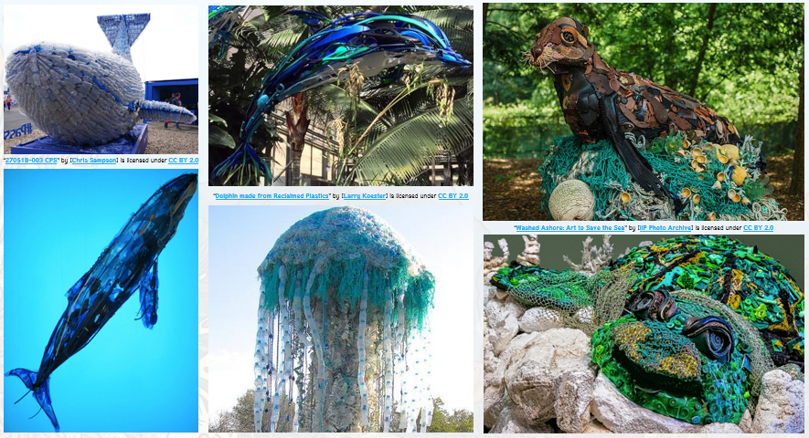
5

