Cuckney C of E Primary School
we
be
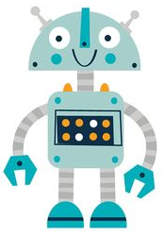

all
me
my

Reading Robot 3

Cuckney C of E Primary School


are
you
was
Reading Robot 4

