Cuckney C of E Primary School
come
some
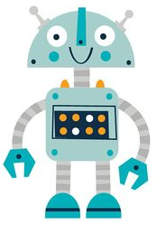

out
when
what

Reading Robot 7

Cuckney C of E Primary School


were
little
there
Reading Robot 8

