Welbeck class - weekly plan Date: 6th July 2020 Theme: Street Art & Science
 | Activity Overview | TASK | Resources Needed | Teacher/Parent Notes
Weekly Premise:
This week our project is ‘End of Year’ and is all about 2019-20, albeit slightly shortened and bizarre this year. The project involves lots of memories, lots of gathering information and a chance to be supportive of class mates.

The work completed by year 6s will be used to make up their end of year leaver’s books. For year 5 this will help shape some class displays for September, support year 4>5 transitional students and to begin their own leaver’s information for Summer 2021.
Monday AM | Mental Maths | Either Read the questions to the children, or if this is not possible, get them to read the question themselves, sticking to the time limit once the questions has been read. | Summer 8b
Monday AM 1 | Maths | Regular and irregular polygons | (Support Videos: https://whiterosemaths.com/homelearning/year-5/)
Monday AM 2 | English/Art | Introduction to Street Art  Ask the childen what they know of graffiti? What do they think of it? Does graffiti carry positive or negative connotations? Does anybody know of any famous pieces of graffiti?  Show the Power point on street art and discuss through the slides. Explain to the children that we are going to focus on a very famous graffiti artist – Banksy. Has anyone heard of him or know any of his works?  Show the Power point on Banksy. Answer the questions on the power point as a class (or if home learning, on a sheet of paper).  Go through different pieces of art by Banksy (Banksy display photos), trying to interpret which each one means.  Complete the sheet Banksy Street Art Activity Sheet - Children write a short explanation of their interpretation of each graffiti art picture.  Complete the bullet pointed follow up tasks. | Power point on street art  Power point on Banksy  Banksy display photos  Banksy Street Art Activity Sheet
Monday PM | Science | You will investigate how a submarine descends and ascends through making a Cartesian diver.  Video explaining process: https://www.youtube.com/watch?v=DU8wONWjIXg  Follow the instructions to make your own.  This investigation links with submarines, as submarines work through water displacement just as your diver does. They carry tanks of compressed air which helps to control their buoyancy. Surrounding a submarine are ballast tanks, which, when filled with water, allow it to dive through increasing its density of the submarine. When the submarine is ready to rise, the water in the ballast tanks is displaced by air from compression tanks, decreasing the density of the submarine causing it to rise to the surface.  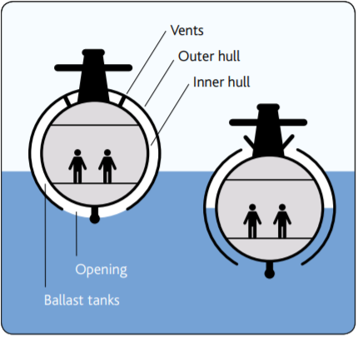 | Cartesian Diver PDF
Tuesday AM | Arithmetic 54 | Children are given 15 minutes to complete their Arithmetic sheet. | Arithmetic 54
Tuesday AM 1 | Maths | Reasoning about 3D Shapes | (Support Videos: https://whiterosemaths.com/homelearning/year-5/)
Tuesday AM 1 | Computing | Programming Angry Birds  Follow this link, https://studio.code.org/s/coursec-2020/stage/4/puzzle/2 to complete the programming challenges
Tuesday AM 2 | Art/English | Banksy’s bank note.  Children design a bank note using Bansky’s Princess Diana £10 note as inspiration. Follow the steps on the banknote activity sheet and complete the additional tasks. | Banksy’s banknote activity sheet.
Tuesday PM | Science | Gustave Eiffle – Building Towers  Watch the video: https://youtu.be/iGRLY08Kn2o exploring how and why we need to build strong towers.  Your Challenge: To build a tall and stable structure using marshmallows and cocktail sticks | Marshmallows  Cocktail Sticks
Wednesday AM | Mental Maths | Either Read the questions to the children, or if this is not possible, get them to read the question themselves, sticking to the time limit once the questions has been read. | Mental Maths Summer 8c
Wednesday AM 1 | Maths | Reflection | (Support Videos: https://whiterosemaths.com/homelearning/year-5/)
Wednesday AM 2 | English | The Clacton Pigeon  Watch the 13.54 minute video ‘Who is Banksy?’ that summarises the enigma of the famous street artist. https://www.youtube.com/watch?v=Xoe3Nn5vuBg  Now look at the short clip ‘Banksy Brexit mural..’ that shows people’s reactions to the mural in the town of Dover in Kent, shortly after it was unveiled. https://www.youtube.com/watch?v=-Jt39sF1NMY  Ask children what they now know about the famous artist having watched the clips. They may now be aware that Banksy:  - Might be one person, or a group of people.  - Is described as an anonymous England-based graffiti artist, political  activist and film director of unverified identity.  - Displays his/her/their art on publicly visible surfaces such as walls.  - Created an anti-theme park called Dismaland and recently, a hotel in  Bethlehem called The Walled Off Hotel.  Show the Clacton Pigeon Mural by Banksy and tell the children the brief story  behind it. Ask the children questions such as:  - What can we see? - What types of birds can we see?  - How are the birds different? - What is this image about?  - Who do the pigeons represent? - Who does the swallow represent?  - Why is immigration in the news so much these days?  Encourage children to consider the ‘racist’ label the mural has been given:  - Why did some people think this is a racist image? Do you agree? Why/Why not?  - Thinking about Banksy’s motivations/political stance – the mural is unlikely to be racist to immigrants, but is it still a prejudicial image? Against who?  - Are ‘British Values’ represented in the mural? Or undermined?  - Do you think the council should have painted over it?  Give children a copy of the Clacton mural. Bearing in mind the absence of ‘British Values’ in the mural, them to look at the piece and discuss how they could change this. They need to alter the image to a more migrant welcoming scene. They could do this by:  - Adding clothes to the pigeons, often referred to as ‘rodents of the sky’ to make them more refined. This would also make them appear more diverse – representative of our multicultural society – as opposed to an angry grey mob/army with the same view  - Add balloons  - Add speech bubbles  - Change the writing on the banners and placards by sticking pieces of paper on top, eg: ‘Welcome to our home’, ‘Room for all’, ‘The more the merrier’, etc  - Add another bird to the image – maybe a baby swallow  Draw their new image. |  | Clacton Pigeon Mural  Youtube links
  Key Questions:
  -What is Brexit?
  -Is the wall mural in Dover making a
  statement about Brexit?
  -What is Banksy saying in this artwork?
  - Do you think his work is art?
  - Who does public art belong to?
Wednesday AM 3 | Science | Use your knowledge of forces to create your very own marble run.  It can be as complicated as you want.  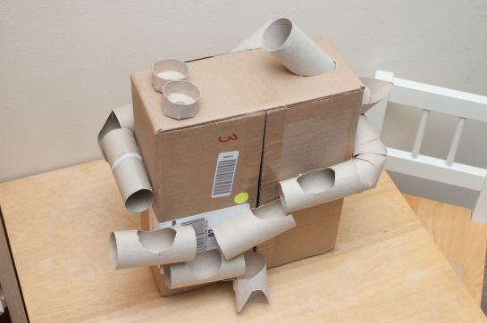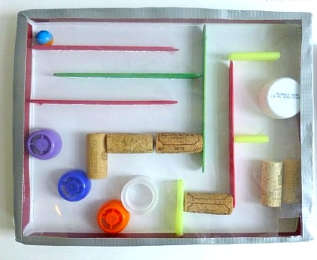  Help video: https://www.facebook.com/dkbooks.uk/videos/1665456436911449/ |  | Recycled materials needed
Wednesday PM | Topic | Big Welbeck Quiz of the Year – Round 2 | BWQOTY – Round 2 Questions
Thursday FIRST THING! | Art | Get some paint out, preferably black or grey and put a small amount on a palette to allow it to semi-dry for using this afternoon – the PM task won’t work with fresh paint!
Thursday AM | Arithmetic 55 | Children are given 15 minutes to complete their Arithmetic sheet. | Arithmetic 55
Thursday AM | Maths | Translation | (Support Videos: https://whiterosemaths.com/homelearning/year-5/)
Thursday AM | English | Show the ‘more examples of Banksy’s work’ power point. DS to read out some of Banksy’s *edited* quotes about his world views. (Parents censor these appropriately)  This afternoon children are going to have a go at making their own stencils to create graffiti art. With that in mind, it’s time to come up with their own inspiration. Think about the issues that have driven Banksy:  - Poverty  - Greed  - Obsession  - Politics  - Health  - War  - Topical issues  Which of Banksy’s pieces of work relate to these themes?  What world issues matter to you? Pollution? Deforestation? Capitalism? Racism? Sexism?  Children choose their issue and write a summary of their choices, using the graffiti idea planning sheet. | More examples of Banksy’s work’  Quotes from Banksy for Debbie to use.  Graffiti idea planning sheet
Thursday PM | Art/Design | Create a stencil  Time to become your own Bansky! Follow the stencil power point for tips on how to create a stencil for producing graffiti art.  Step One:- Decide on a piece of art – what message do you want to convey? Think back to this morning’s English session.  Step Two:- Cut out a stencil using card or good quality paper.  Step Three:- Use a piece of sponge to lightly press semi-dried paint onto paper underneath the stencil. It is important that the paint isn’t fresh as it won’t impress the faded ‘hole’ appearance of the sponge.  Step Four:- Add your ‘tag’ to sign the piece of art and stencil any lettering to create a message. |  | Stencil power point
Friday AM | Mental Maths | Either Read the questions to the children, or if this is not possible, get them to read the question themselves, sticking to the time limit once the questions has been read. | Summer 8 c
Friday AM | Maths | Family Maths Challenge  There are 10 challenges dated Friday 26th June (yes, I know that was last week!)  Challenge 1 and 2 are aimed at KS1 children. If your child has a sibling in a younger year group, encourage them to do this challenge with them – letting the younger sibling solve the problem, but using their mathematical language to help guide them.  Challenges 3, 4, 5 and 6 are suitable for Welbeck children to tackle independently.  Challenges 7, 8, 9 and 10 are aimed at Secondary school children. If your child has a sibling at secondary school, encourage them to work together with the older child taking the ‘teacher’ role to help explain the problems to their Welbeck sibling.  Obviously if you don’t have a sibling that fits into either category, aim to answer the first 6. Anything on top of that is a bonus! | Family Maths Challenge  The answers are also available at https://whiterosemaths.com/homelearning/year-5/)
Friday AM 1 | English | Banksy Reading Comprehension  Read the Banksy Fact File (3*) and answer the questions on the Reading Comprehension sheet.  Ask the children to leave the questions subtitled ‘Painting for Saints’ until after break time. | Banksy Fact File  Banksy Reading Comprehension
Friday AM 2 | English | Painting for Saints  Show Banksy’s latest piece of art – Painting for Saints  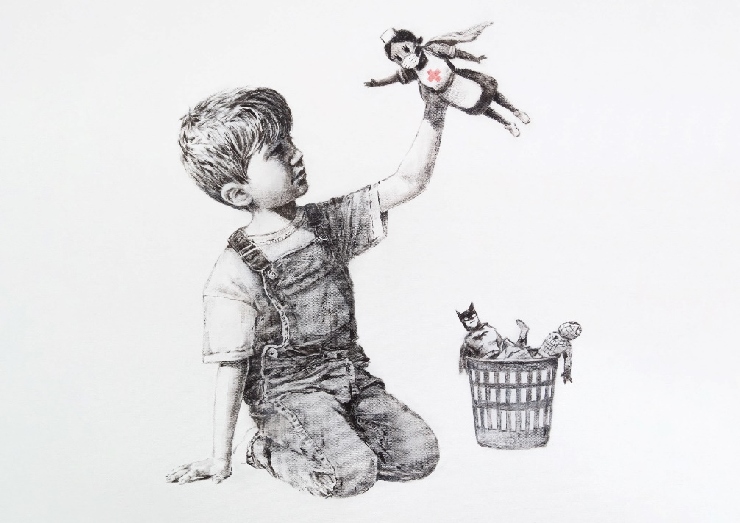  Analyse the picture and answer the questions that go with it.  What is happening in the picture?  Explain that Banksy’s latest piece of work was completed during the COVID19 outbreak and he has painted this at Southampton General Hospital. Bansky has stated that they can auction it off to raise funds for the NHS.  *Extension questions on the reading comprehension sheet – Who do you think Banksy could be and why? | Painting for saints image  Painting for Saints questions on the reading comprehension sheet.
Friday PM | Art/Design/Film | Finishing off – creating a secondary stencil – film on in the background.

